NutriGuide — Multi-Agent Workflow
Milestone II Design Document
Rekha Wulfekuhle
CIS 4394 – Agentic AI | Dr. Xinyu Fu
Due: March 25, 2026

1. What NutriGuide Does
NutriGuide is a nutrition tracking app built for college students. The idea came from my proposal — most calorie apps feel like a chore, and students usually give up after a few days. The goal was to make logging feel more natural by just letting people type what they ate in plain English.

For Milestone II the main task was building out the actual agent pipeline. Instead of one big function doing everything, I split the work across six agents that each handle one piece of the problem. The flow goes: Planner → Interpreter → Nutrition DB → Calculator → Coach → Safety. Each agent takes in a shared state object, does its job, and passes the updated state to the next one.

2. Architecture Diagram
The diagram below shows all six agents, what tools they use, how data flows between them, and where state/memory lives. I tried to lay it out so you can follow the path from user input all the way to the final response.

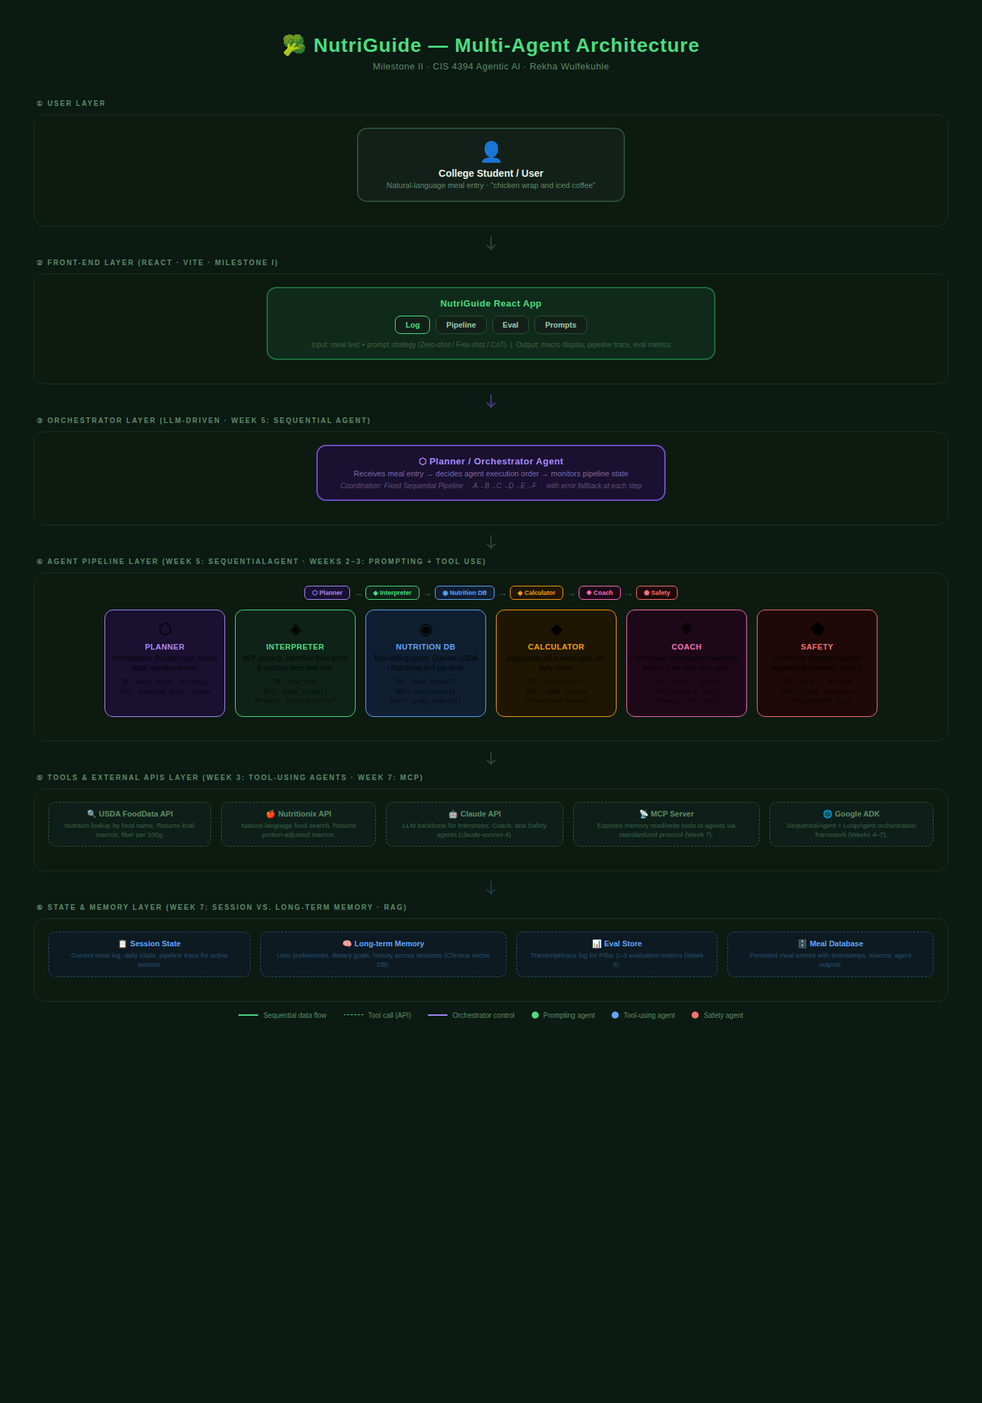
Figure 1 – NutriGuide agent architecture (Milestone II)

3. Agents – Roles and I/O
There are six agents total. I'll go through each one and explain what it does, what it takes in, and what it outputs.

3.1 Planner Agent
This is the entry point. When a user submits a meal, the Planner is the first thing that runs. It checks if the input is valid, sets up the pipeline state object, and defines the order that the other agents will run in.

I based this on the LLM-driven orchestrator pattern we looked at in Week 5 (the Research & Summarization example). The coordinator decides what runs next — in NutriGuide's case the order is always fixed, but the Planner still owns the routing logic.

- Input: meal text from the user, prompt strategy choice (zero-shot / few-shot / CoT)
- Output: initialized PipelineState object with routing plan and empty fields for downstream agents
- If the input is blank or too short: return an error early, don't start the pipeline

3.2 Food Interpreter Agent
This one does the NLP work. It takes the raw meal text and figures out what foods are in it and roughly how much of each. So "chicken wrap and iced coffee" becomes two items with estimated portions.

This is where the three prompting strategies from Week 2 come in. Depending on what the user picks, the system prompt changes:

- Zero-shot: just the role + task + output format. No examples. Works fine for simple entries.
- Few-shot: includes 3 labeled examples before the actual input. Helps a lot when entries are phrased weirdly.
- Chain-of-Thought: asks the model to identify each item step by step before giving the final JSON. Slower but more accurate for complex entries.

- Input: meal text string + strategy
- Output: food_items[] — array of objects with name, quantity, unit
- If the model returns an empty array: fall back to treating the whole entry as one item

3.3 Nutrition DB Agent
This is the tool-calling agent. It loops through the food items from the Interpreter and looks up the nutrition data for each one. In the current version I'm using a mock database with realistic values — the plan for Milestone III is to replace it with real USDA and Nutritionix API calls.

I set this up as a separate agent (rather than just part of the Interpreter) because tool use should be its own step. We talked about this in Week 3 — the agent stack has tools as a distinct layer below the model.

- Input: food_items[] from the Interpreter
- Output: nutrients[] — one entry per food item with calories, protein, carbs, fat, fiber
- If an item isn't found in the database: flag it as not_found and continue with the rest

3.4 Calculation Agent
This one doesn't call an LLM. It just adds everything up. Takes the nutrients array and sums it into daily totals, then calculates what percentage of the user's goals each macro is at.

I kept this as a pure function because there's no reason to use an LLM for simple arithmetic. We talked in class about how structured output is the goal for steps like this — the output schema is fixed and validated before passing it along.

- Input: nutrients[] from the DB agent, existing daily totals, user goals
- Output: totals object — { cal, protein, carbs, fat, fiber } plus pct_of_goal
- Edge case: negative or null values get clamped to 0

3.5 Wellness Coach Agent
This agent takes the numeric totals and turns them into a short piece of advice. Two sentences, friendly tone, nothing preachy. I used few-shot prompting with a style spec here — the same concept from Week 2 where you replace vague adjectives like "sound encouraging" with actual constraints (audience, tone, length, banned phrases).

I included 3 examples in the system prompt so the model has a sense of what the right length and tone looks like. If the API fails for any reason, there's a fallback that generates a basic message from the numeric totals without needing an LLM call.

- Input: daily totals, user goals
- Output: advice string — exactly 2 sentences, no medical claims, no numbers
- If API errors: use templated fallback based on whether protein is low, calories are low, etc.

3.6 Safety Monitor Agent
Last agent in the chain. It checks the totals for anything that looks extreme and always appends a disclaimer to the final output. No LLM call here either — it's just a set of if-statements.

This connects to a few things from class. In Week 5 we built safety agents into the pipeline. In Week 8 we covered Pillar 3 (trust and safety) as part of evaluation. The instruction hierarchy from Week 2 also applies here — safety constraints are SYSTEM level, so they run regardless of what the user asked for.

- Input: totals, meal log, advice text from Coach
- Output: final response string, safety_flag boolean, disclaimer
- Checks: cal < 300 → low intake warning. cal > 2500 → high intake note.
- Disclaimer is appended every time, no exceptions — even if the Safety agent itself errors

4. How the Agents Are Coordinated

4.1 Pipeline Type
I went with a fixed sequential pipeline (A → B → C → D → E → F). This made sense for NutriGuide because each step depends on the previous one — you can't calculate totals before you have nutrients, and you can't look up nutrients before you've parsed the food items. There's no branching or parallel work needed.

This matches what we built in Week 5 with the SequentialAgent in Google ADK. The BlogPipeline example (Outline → Writer → Editor) has the same structure.

Step | Agent | Gets input from | Sends output to
1 | Planner | User (front-end) | Interpreter
2 | Interpreter | Planner | Nutrition DB
3 | Nutrition DB | Interpreter | Calculator
4 | Calculator | Nutrition DB | Coach
5 | Coach | Calculator | Safety
6 | Safety | Coach | Front-end

4.2 Shared State Object
All six agents read from and write to the same PipelineState object. The Planner creates it at the start, each agent adds its results, and the Safety agent's output is what gets returned to the front-end. The trace[] array inside the state is what populates the Eval tab — each agent adds a record of what it did, which is the "transcript" we covered in Week 8.

PipelineState = {
meal_text: string, // original input
strategy: string, // zero-shot | few-shot | cot
food_items: FoodItem[], // set by Interpreter
nutrients: NutrientData[], // set by Nutrition DB
totals: MacroTotals, // set by Calculator
advice: string, // set by Coach
final: FinalResponse, // set by Safety
errors: ErrorLog[], // accumulated across all agents
trace: TraceEntry[] // used for eval (Week 8)
}

4.3 Stopping Conditions
Since it's a fixed pipeline there's no loop to stop — but there are a couple of exit conditions:

- If the Interpreter gets back an empty food_items[] after one retry, the pipeline stops and returns an error message asking the user to rephrase.
- If the Safety agent detects a very extreme pattern across multiple days (not implemented yet, planned for Milestone III), it would stop and return a resource link instead of advice.
- All other failures are soft — the pipeline keeps going with whatever partial data it has and flags the error in the trace.

5. Handling Failures and Bad Outputs
I tried to make sure the app doesn't just crash if something goes wrong. Here's how each main failure case is handled:

What goes wrong | Which agent | What happens
Entry is too vague to parse | Interpreter | Retry once; if still empty, ask user to rephrase
USDA API times out (Milestone III) | Nutrition DB | Try Nutritionix fallback; use mock data if both fail
Item not found in any source | Nutrition DB | Skip that item, flag it, continue with the rest
Coach output seems off-topic | Coach | Fallback to templated message from totals
LLM API returns an error | Interp / Coach | Retry once; use fallback if second attempt fails
Safety agent itself errors | Safety | Static disclaimer is still appended no matter what

The general approach is: try to recover gracefully and keep going rather than showing a blank error screen. Everything gets logged in the errors[] and trace[] arrays so I can see what's failing during evaluation.

6. Example Data Flow
Just to make it concrete, here's what happens when someone types "chicken wrap and iced coffee":

User types: "chicken wrap and iced coffee"
↓ Planner: creates state, sets plan
↓ Interpreter [Zero-shot]: food_items = [
{ name: 'chicken wrap', quantity: 1, unit: 'serving' },
{ name: 'iced coffee', quantity: 1, unit: 'serving' }
]
↓ Nutrition DB: looks up both items →
chicken wrap: { cal: 480, protein: 34, carbs: 45, fat: 14 }
iced coffee: { cal: 70, protein: 1, carbs: 11, fat: 2 }
↓ Calculator: totals = { cal: 550, protein: 35, carbs: 56, fat: 16 }
↓ Coach: "You're making solid choices today! Adding a piece of
fruit later could help you hit your fiber goal."
↓ Safety: no flags → append disclaimer → send to front-end

The whole thing takes around 2–3 seconds end-to-end (most of that is the LLM calls). Each step is visible in the Pipeline tab as it runs.

7. What's Planned for Milestone III
- Hook up real USDA and Nutritionix API calls in the Nutrition DB agent
- Run a set of ~20 test entries and score them using code-based graders (macro accuracy) and model-based graders (advice quality)
- Report on the 3-pillar metrics from Week 8 — especially Pillar 2 (tool selection accuracy, latency) and Pillar 3 (safety flag rate)
- Add basic memory persistence using local storage so daily goals survive a page refresh

NutriGuide · Milestone II · CIS 4394 Agentic AI · Rekha Wulfekuhle

